Role-Based Access Control (RBAC) Design and Implementation using Microsoft Entra ID

1. Introduction
Role-Based Access Control (RBAC) is a fundamental concept in Identity and Access Management (IAM) that restricts system access based on user roles. It helps organizations enforce security policies, reduce excessive access, and ensure that users only have permissions required for their job functions.
This project demonstrates the design and implementation of an RBAC model using Microsoft Entra ID.

2. Objective
The objective of this project is to:
- Design an RBAC model based on job roles
- Assign access to applications based on roles
- Enforce the principle of least privilege
- Validate access boundaries through testing
- Simulate real-world IAM access control scenarios

3. Tools & Technologies Used
- Microsoft Entra ID (Azure Active Directory)
- Azure Portal
- Enterprise Applications
- MyApps Portal (https://myapps.microsoft.com)

4. Architecture Overview
The environment simulates an organization with:
- IAM Administrator (Admin account)
- Users:
  - Jane (HR)
  - Chris (Finance)
  - Alex (IT)
- Applications:
  - HR App
  - Finance App
  - IT Tool
Due to free-tier limitations, direct user-to-application assignment is used instead of group-based RBAC.
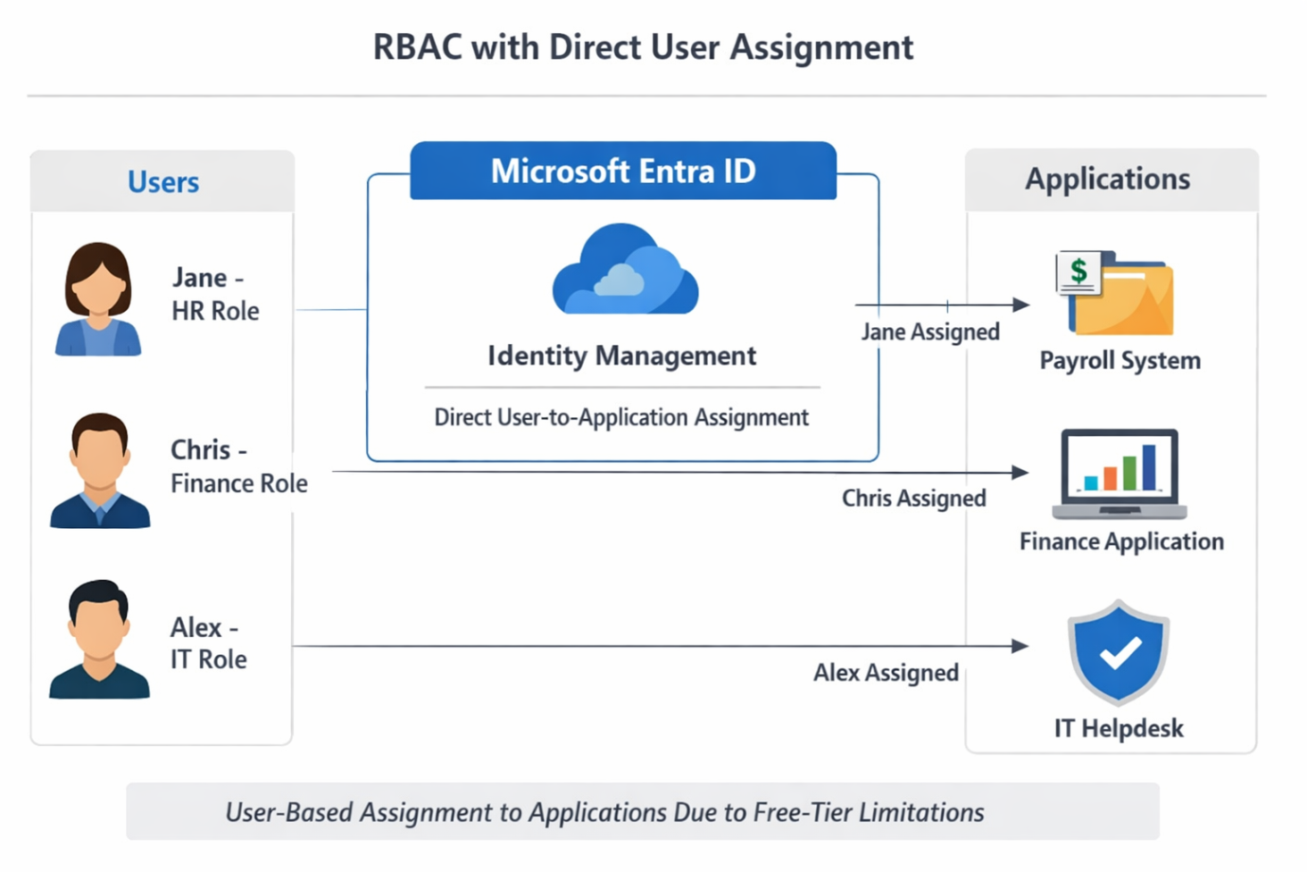
Architecture Diagram of RBAC

5. Environment Setup

Steps Performed:
- Logged into Azure Portal
- Navigated to Microsoft Entra ID
- Verified tenant configuration
- Prepared environment by ensuring no conflicting assignments
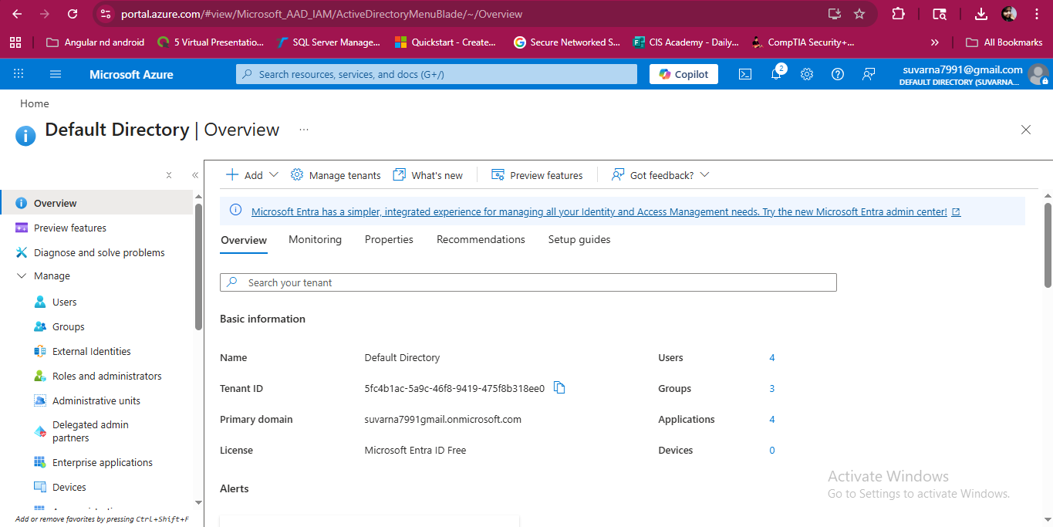
Entra_ID Overview

6. User Creation
Users were created to represent different job roles.

Users:
- Jane – HR Department
- Chris – Finance Department
- Alex – IT Department

Steps:
- Navigated to Entra ID → Users
- Created users with temporary passwords
- Enabled accounts
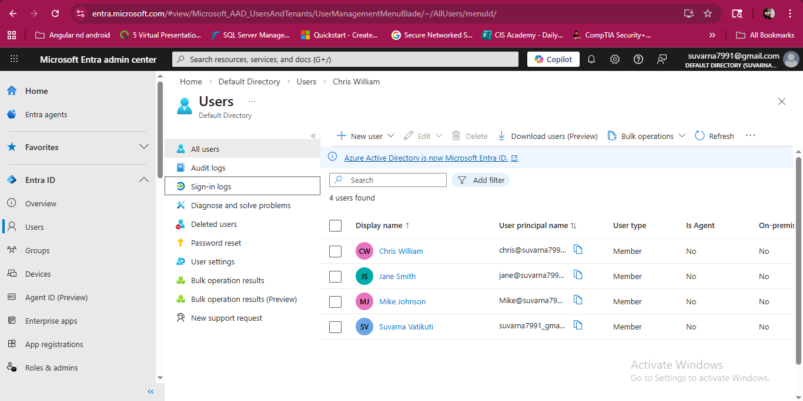

7. Application Setup
Enterprise applications were created to simulate business systems.

Applications:
- HR App
- Finance App
- IT Tool

Steps:
- Navigated to Enterprise Applications
- Selected “Create your own application”
- Configured application details
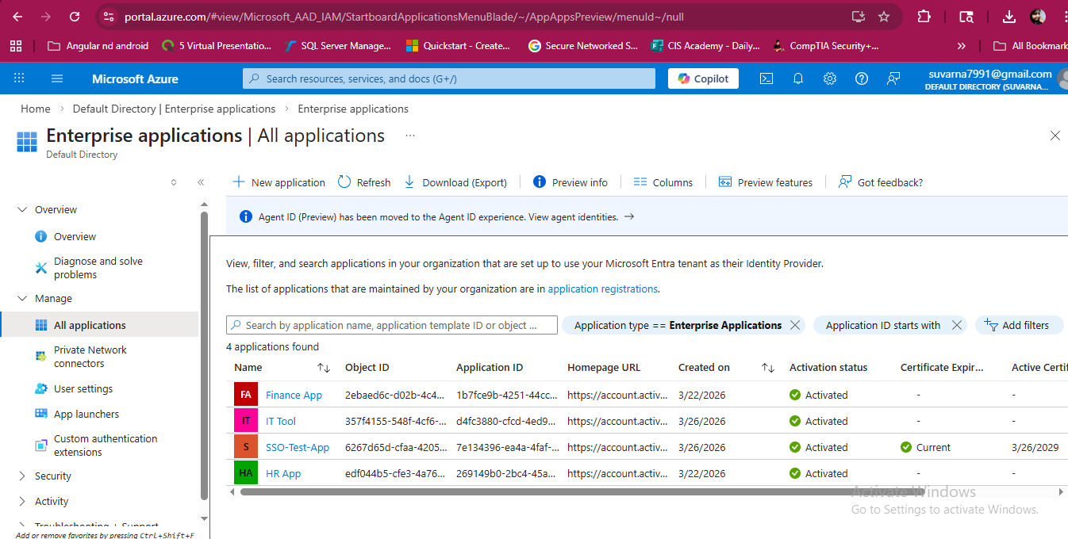
Enterprise Applications List in Entra ID

8. RBAC Design

Role Definitions:
Role | Access
HR | HR App
Finance | Finance App
IT | HR App + Finance App + IT Tool

Important Note: Due to free-tier limitations of Microsoft Entra ID, group-based RBAC was not available. Therefore, role-based access was implemented using direct user-to-application assignments while maintaining RBAC design principles.

9. Access Assignment (Implementation) Access was assigned based on defined roles.

Assignments:
- Jane → HR App
- Chris → Finance App
- Alex → HR App, Finance App, IT Tool

Steps:
- Navigated to Enterprise Applications
- Selected each application
- Assigned users individually
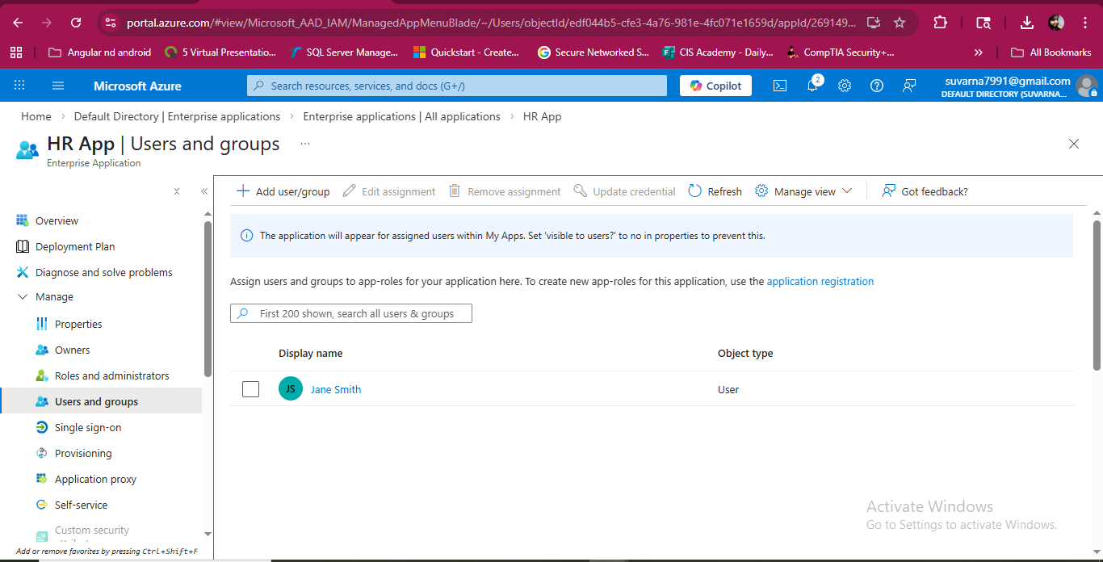 HR App Assignment
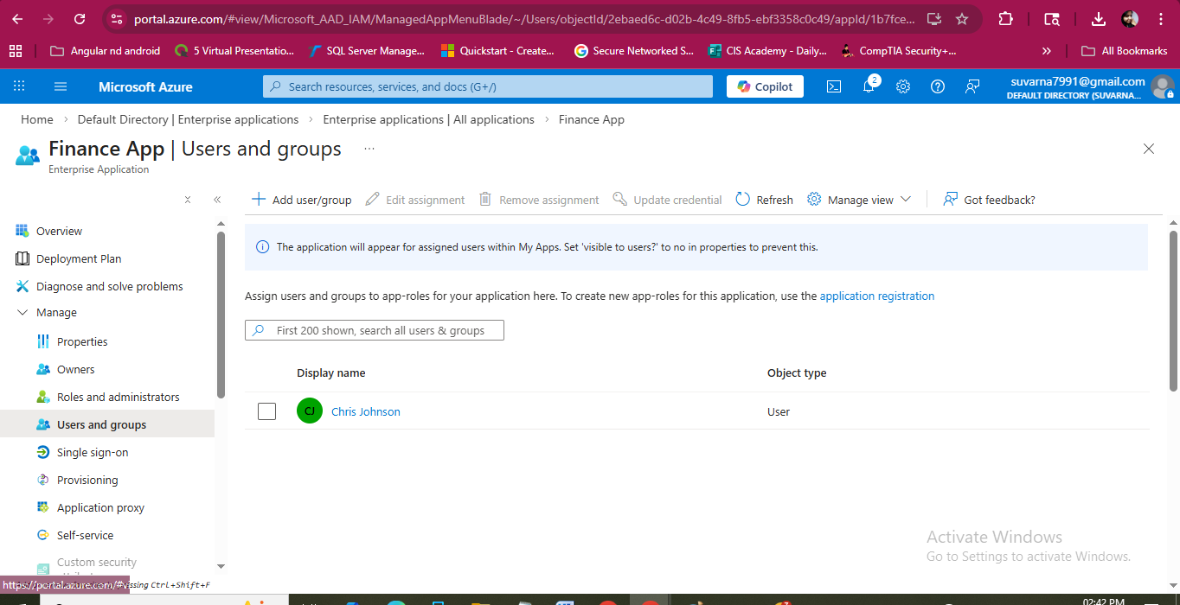Finance App Assignment
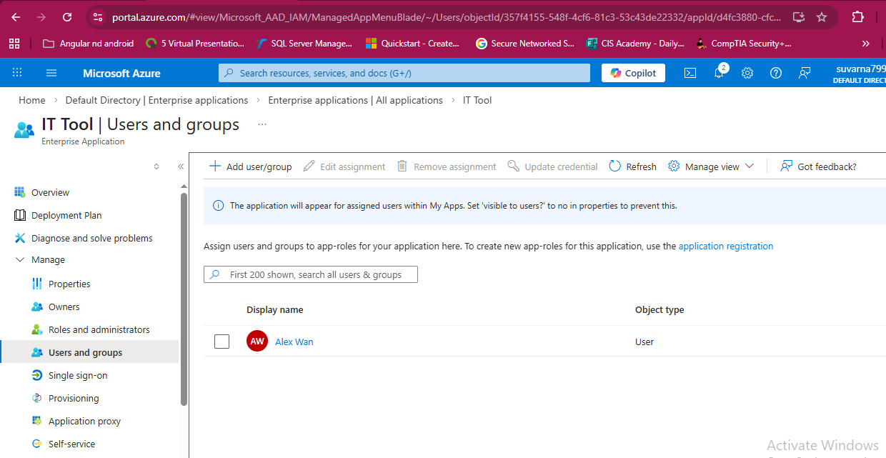
IT Tool Assignment

10. Access Validation (Testing)
Access was tested using MyApps Portal.

Results:

Jane:
- Access to HR App ✔
- No access to Finance App ❌

Chris:
- Access to Finance App ✔
- No access to HR App ❌

Alex:
- Access to all applications ✔

Steps:
- Logged in as each user
- Verified visible applications
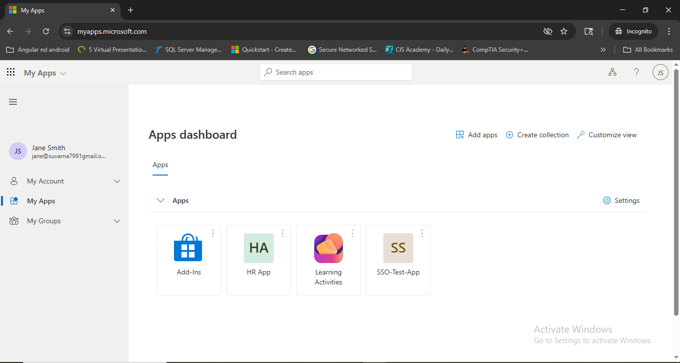
MyApps Screenshot – Jane
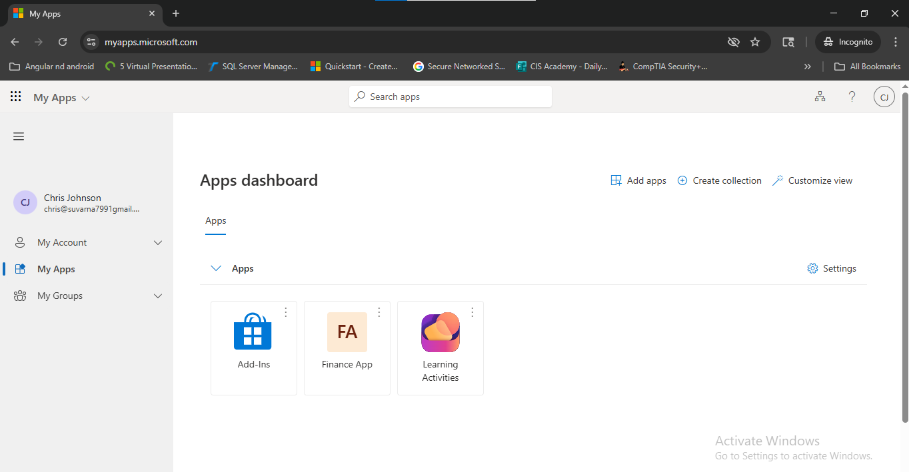
MyApps Screenshot – Chris

11. Edge Case Testing
Additional tests were performed to validate RBAC enforcement.

Test Cases:
- Removed Jane from HR App → No access
- Assigned Jane to Finance App → Access updated
- Verified no unintended access

Result:
Access boundaries were strictly enforced.
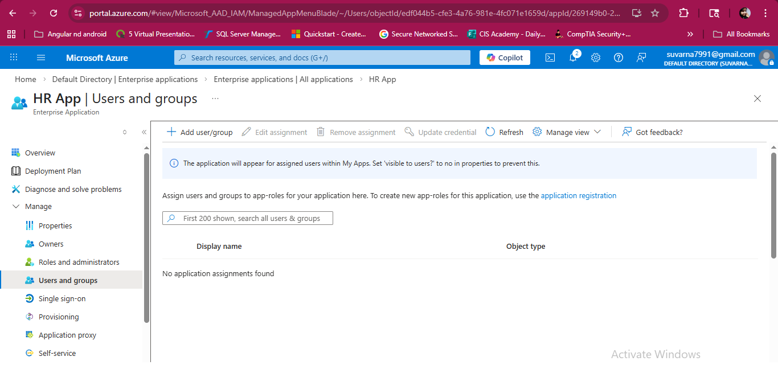
Validation step screenshot

12. Least Privilege Enforcement

The principle of least privilege was applied by ensuring:
- Users received only necessary access
- No excessive permissions were granted
- Access was removed when not required
This reduces security risks and prevents privilege creep.

13. Audit Logs and Monitoring
Audit logs were reviewed to validate actions.

Logs Checked:
- User assignment events
- Application access changes
- Sign-in activities

Steps:
- Navigated to Entra ID → Monitoring → Audit Logs
- Verified recorded actions
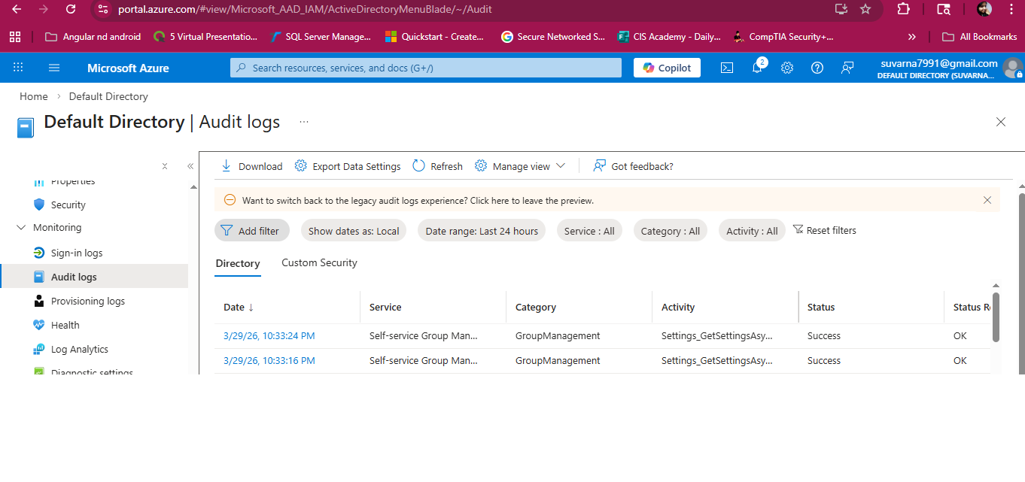Audit Logs Screenshot
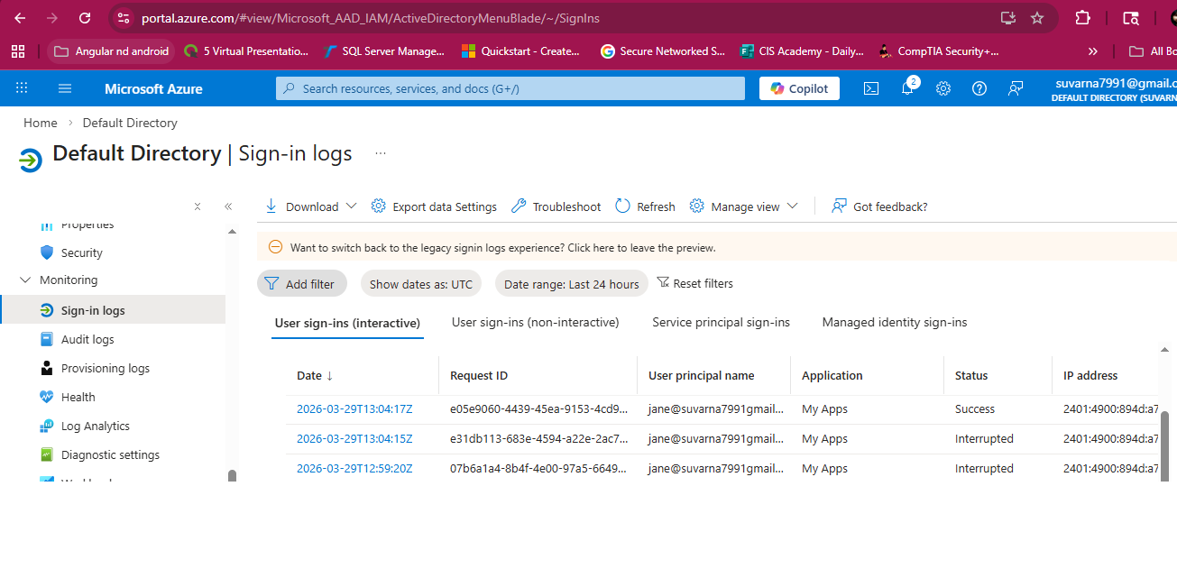
Sign-in Logs Screenshot

14. Security Improvements
This RBAC implementation improves security by:
- Reducing attack surface
- Preventing unauthorized access
- Enforcing structured access control
- Improving audit readiness

15. Key Learnings
- Designing RBAC models based on job roles
- Implementing least privilege access
- Validating access control through testing
- Understanding Azure AD limitations and workarounds
- Real-world IAM access control implementation

16. Conclusion
This project successfully demonstrates the implementation of a Role-Based Access Control model using Microsoft Entra ID. Despite platform limitations, RBAC principles were effectively applied through structured access assignments and validation.
The project highlights how organizations can control access, reduce risk, and improve security posture using IAM best practices.

17. Future Enhancements
- Implement group-based RBAC (with premium license)
- Add Conditional Access policies
- Integrate with HR systems for automation
- Use dynamic groups for scalability

